Documentation for cloud function

1. To set up the cloud function,follow the steps shown in this link. <https://youtu.be/DYfP-UIKxH0>
2. Then open the command prompt in the directory where you’ve created the function and open it using vs code.

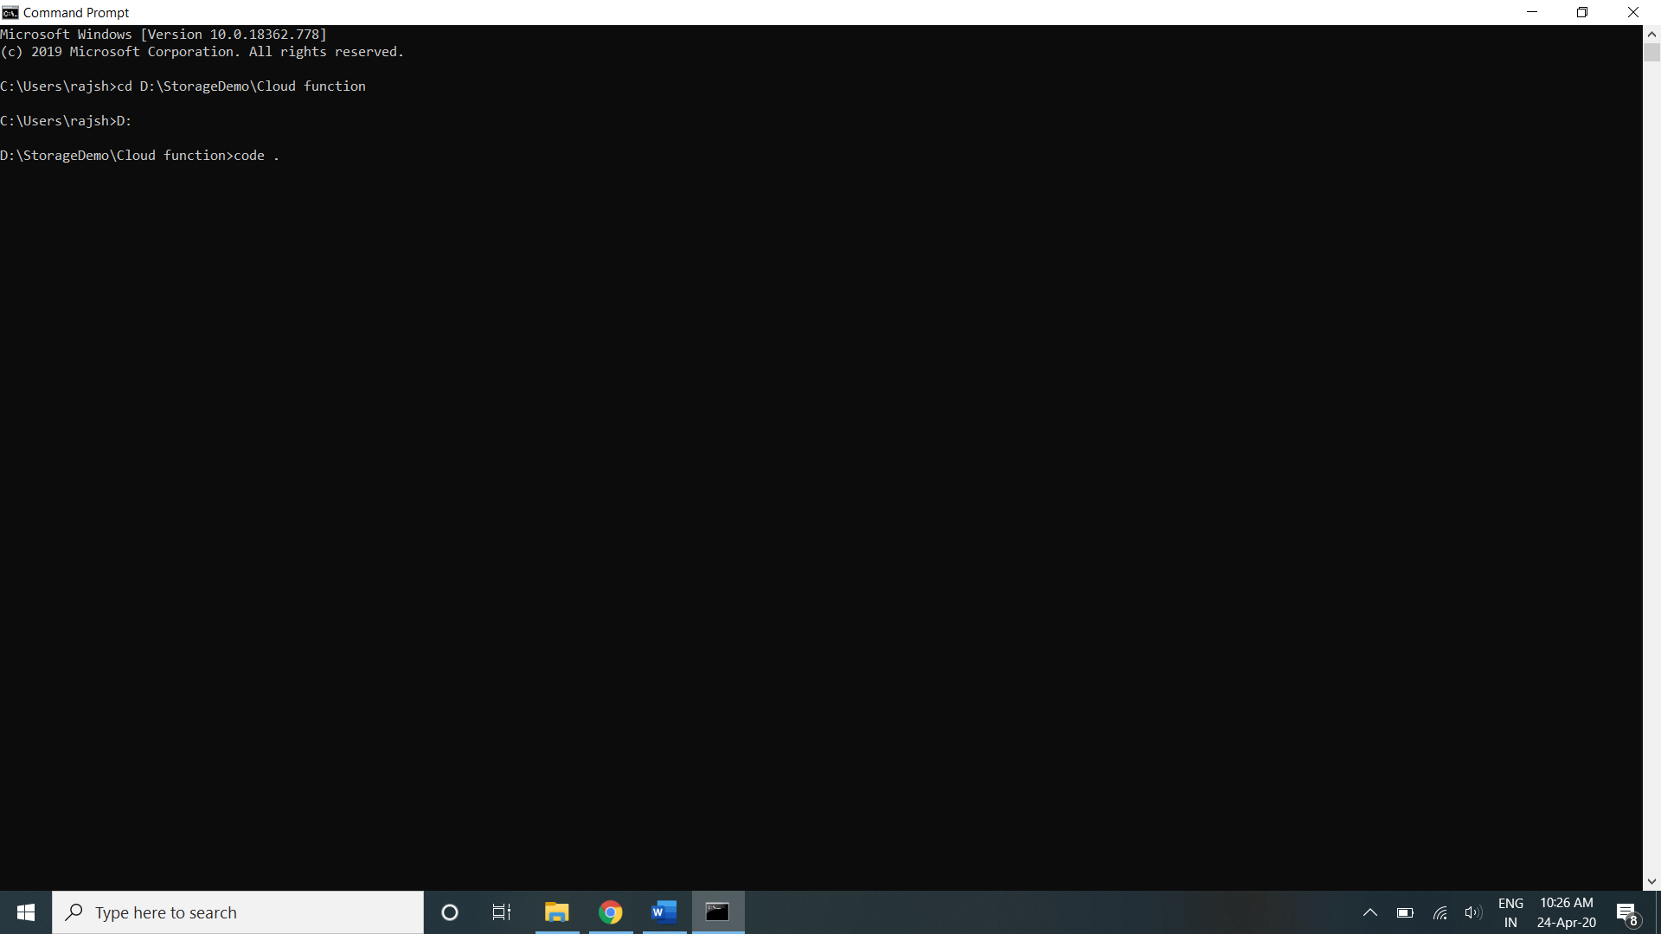

1. It will open vs code with all the existing code. The function will be defined in index.js file in the functions directory.

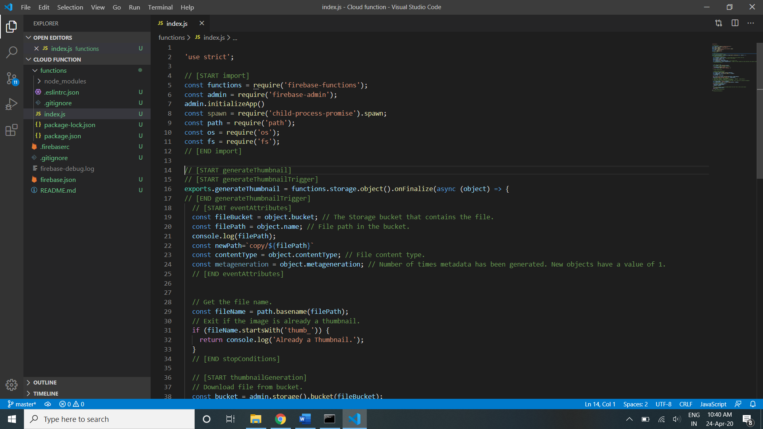

1. Modify the function if required in index.js file
2. Go to the functions directory in your cloud function and in the command prompt, type npm install to install the required the packages

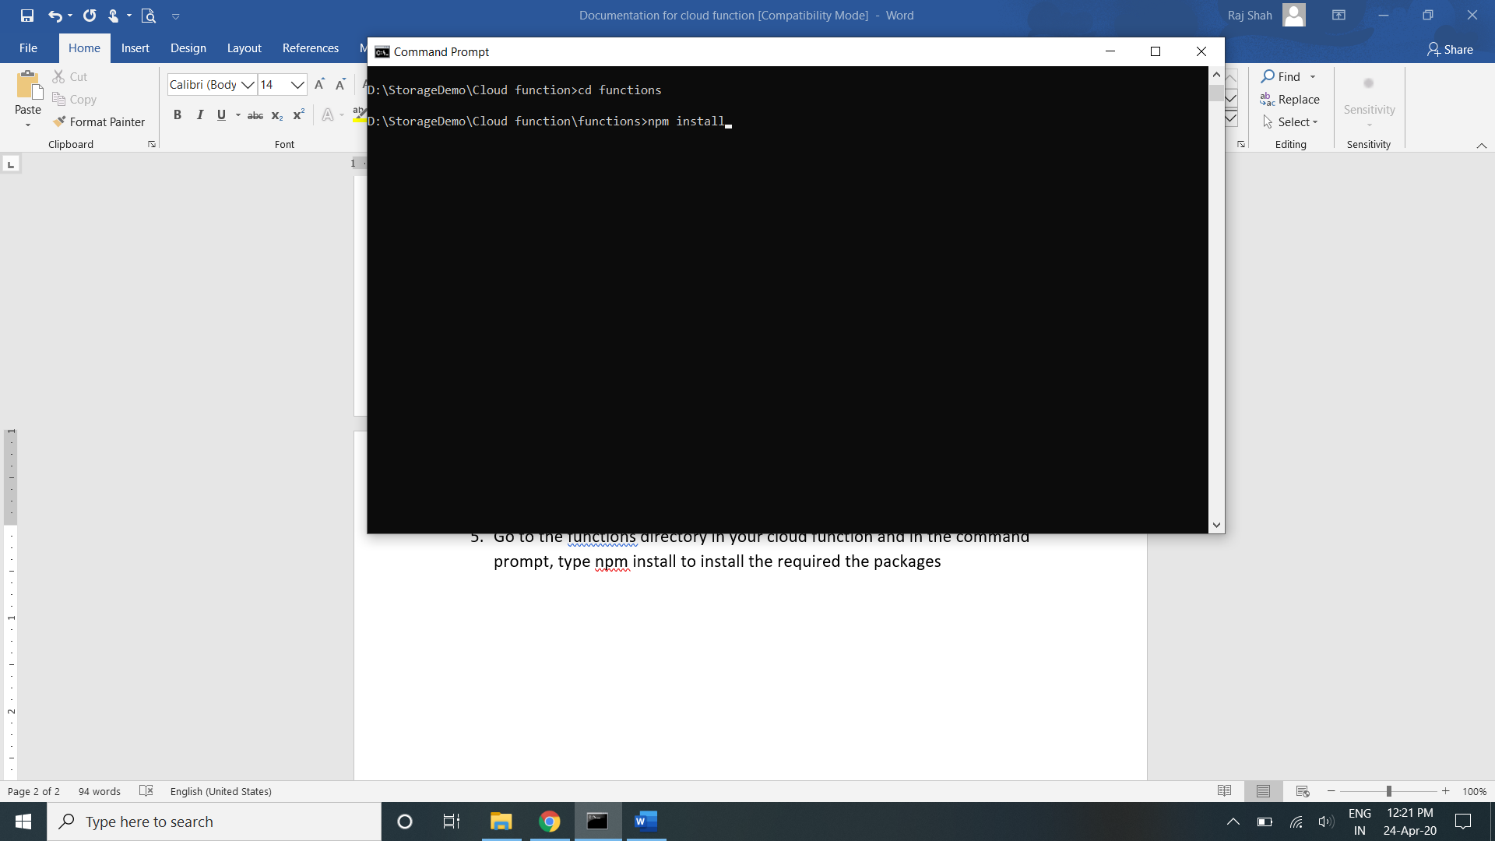

1. Once done editing the function, type firebase deploy to launch the function.

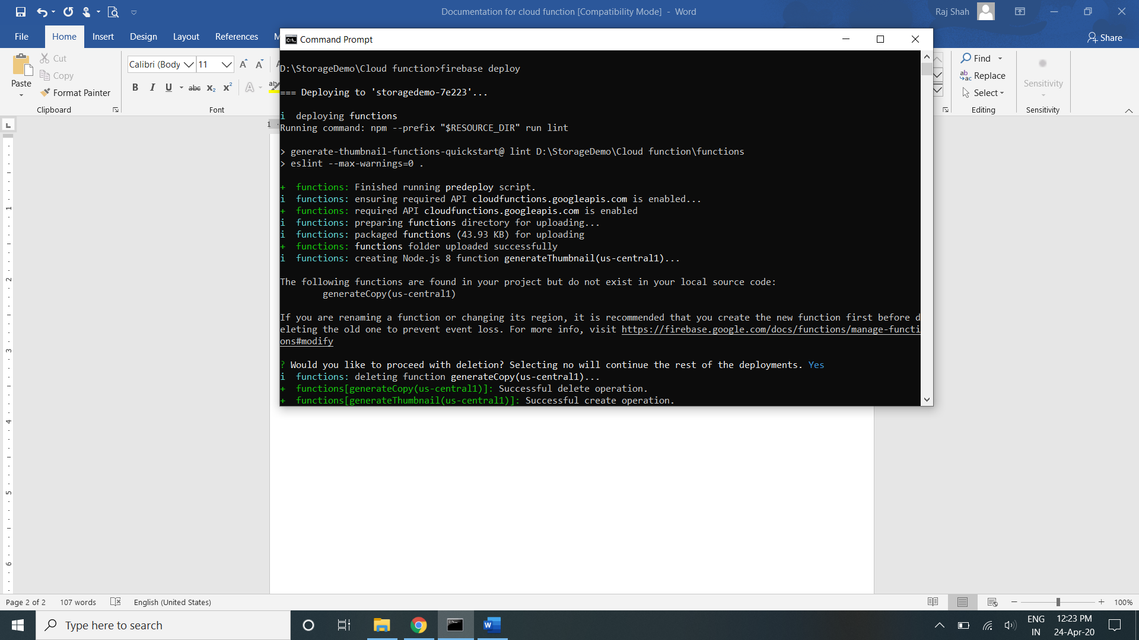

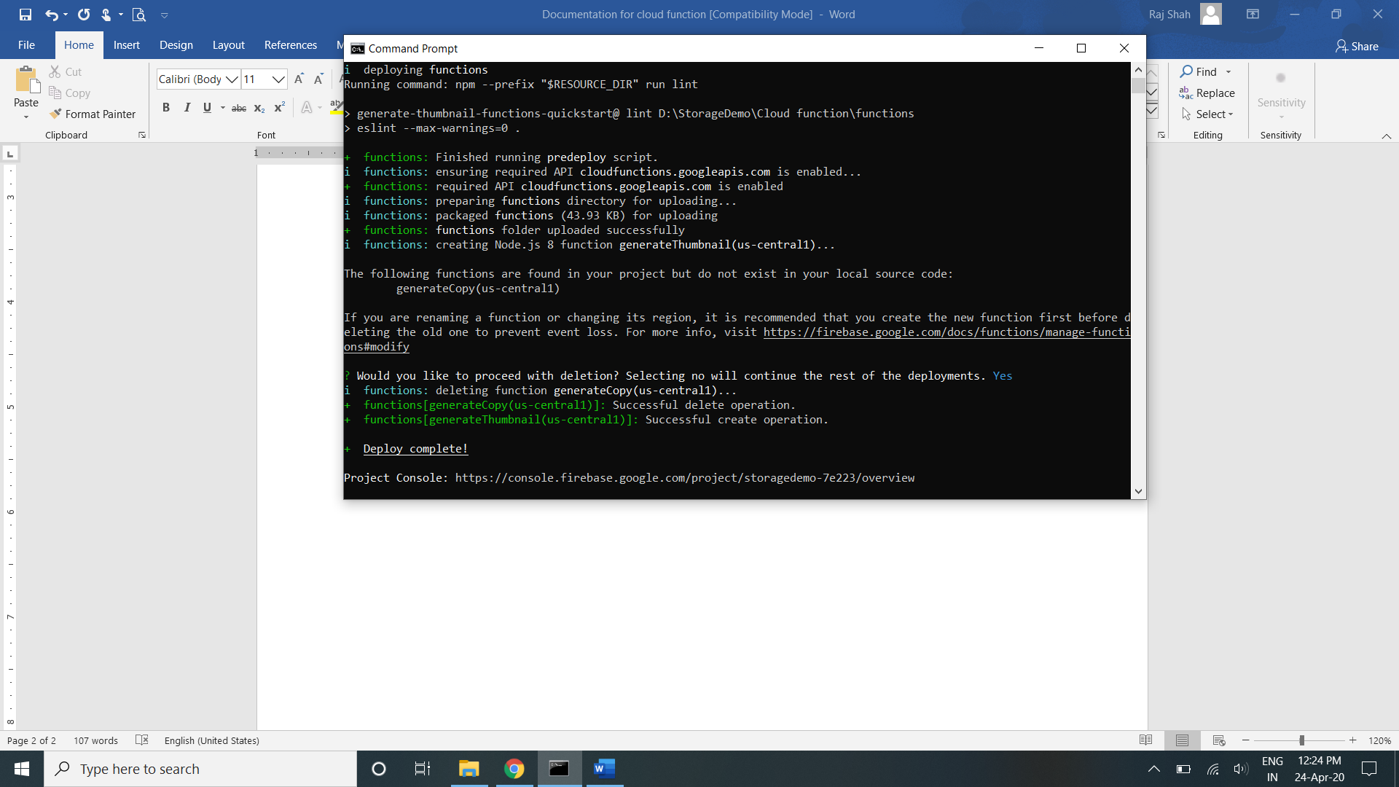

Refernces:

<https://github.com/firebase/functions-samples/tree/master/quickstarts/thumbnails>